**LABTASK 9**

**NAME: SARIM AMIR**

**SID: 63686**

**9.1**

import cv2

import numpy as np

image = cv2.imread("C:/Users/Sarim Amir/Desktop/image1.jfif",flags=cv2.IMREAD_COLOR)

cv2.imshow('Normal Image',image)

image_blur = cv2.blur(src=image,ksize=(75, 75))

cv2.imshow('Blurred Image',image_blur)

cv2.waitKey()

**OUTPUT:**



**9.2**

**PICTURES USED:**

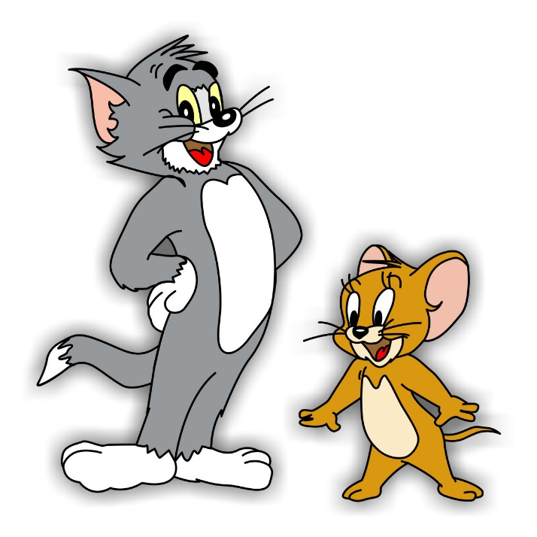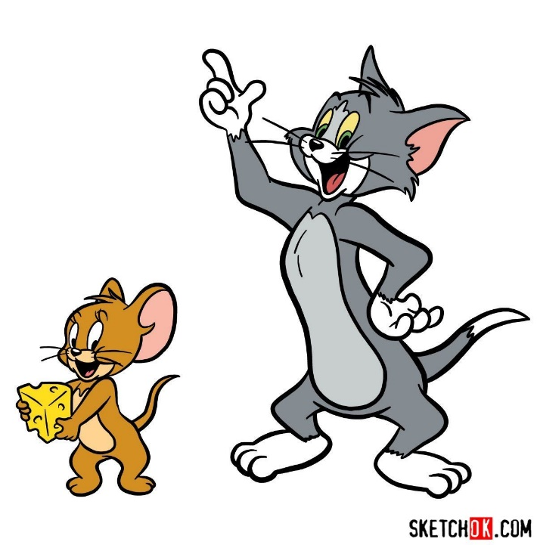

from google.colab import files

import cv2

import numpy as np

import matplotlib.pyplot as plt

img1 = cv2.imread('1.jpg')

img2 = cv2.imread('2.jpg')

images = np.concatenate((img1,img2),axis=1)

cv2_imshow(images)

cv2.waitKey()

cv2.destroyAllWindows()

gray_img1 = cv2.cvtColor(img1,cv2.COLOR_BGR2GRAY)

gray_img2 = cv2.cvtColor(img2,cv2.COLOR_BGR2GRAY)

hist1 = cv2.calcHist(gray_img1,[0],None,[256],[0,256])

hist2 = cv2.calcHist(gray_img2,[0],None,[256],[0,256])

plt.subplot(121)

plt.title("Image1")

plt.xlabel('bins')

plt.ylabel('No. of pixels')

plt.plot(hist1)

plt.subplot(122)

plt.title("Image2")

plt.xlabel('bins')

plt.ylabel('No. of pixels')

plt.plot(hist2)

plt.subplot(122)

gray_img1_eqhist = cv2.equalizeHist(gray_img1)

gray_img2_eqhist = cv2.equalizeHist(gray_img2)

hist1 = cv2.calcHist(gray_img1_eqhist,[0],None,[256],[0,256])

hist2 = cv2.calcHist(gray_img2_eqhist,[0],None,[256],[0,256])

plt.subplot(121)

plt.plot(hist1)

plt.subplot(122)

plt.plot(hist2)

plt.show()

eqhist_images = np.concatenate((gray_img1_eqhist,gray_img2_eqhist),axis=1)

cv2_imshow(eqhist_images)

cv2.waitKey(0)

cv2.destroyAllWindows()

**OUTPUT**

